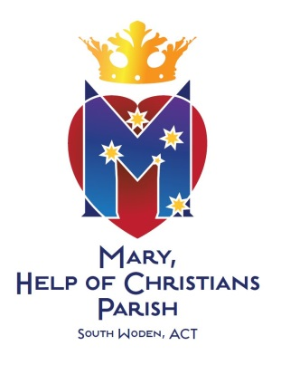
BAPTISM REQUEST & CONSENT FORM
SOUTH WODEN PARISH

Please complete and return to: Parish Office Manager
or via this return email address Sacred Heart Catholic Church,
wodensouth@cg.org.au 115 Hodgson Cres, PEARCE ACT 2607

Phone: 02 6286 1908
Child’s Surname:
Child’s Christian Names: M/F (Please circle)
Address:
(if you live outside of the South Woden Parish, as a courtesy we will notify your Parish Priest of the baptism once it has taken place)

Email:
Would you like to receive the weekly Parish Bulletin via email? Y / N N/A (already receiving)

Child’s Date of Birth: City of Birth:

Location of Marriage &/or Church Name:
Date of Marriage: City/State of Marriage:
(if parents are not married in the Catholic Church, they will need to talk to Fr Emil prior to finalising the baptism)

Father’s Full Name: Father’s Religion:
(if it is to be included on the certificate)
Mobile Phone: Home Phone:

Mother’s Full Name: Mother’s Religion:
(if it is to be included on the certificate)
Mother’s Maiden Name:
Mobile Phone: Home Phone:

Proposed Date of Baptism: Time:
Place of Baptism: Sacred Heart Catholic Church

Celebrant: Fr Emil Milat

*Godparents: First: Second:
Religion: Religion:

Notes:
1. * You may select more than one Godparent, but at least one of the Godparents/Christian witnesses must be a Confirmed Catholic. A proxy (stand in) may represent Godparents.
2. Please ensure your child is wearing a white garment or has a white garment to be presented to them.
3. It is customary to make a financial donation to the Church to help with the running of the Parish.

Parent Declaration:

We request the Sacrament of Baptism for our child
Full name of child to be baptised:

……………………………………………………………………………………

We understand that Baptism is a Sacrament which gives the life of Christ to our child and that it makes our child a member of God's family, the Catholic Church.

And further:
- We accept the responsibility of training our child in the practice of the faith and accept the duty of bringing our child up to keep God's Commandments as Christ taught us, by loving God and our neighbour.
- We understand the need to teach our child by the example of true Catholic living, to encourage family prayer and remain faithful to the attendance of Sunday Mass.
- We are aware of the need to prepare our child for the other Sacraments: Reconciliation, Communion and Confirmation.

We pray that God will keep us faithful to our obligations.
SIGNED......................…………...………and.........……................…………...

NON CHRISTIAN PARENT (if necessary)
I find myself unable to profess my faith as explained above. I still wish my child to be baptised in the Catholic Church, and will assist my spouse as best I can in bringing our child up as a child of God.

SIGNED..........................................……………………………………..…

DECLARATION BY GODPARENTS (Catholic)

We.........................................…………..……and…………………………………have undertaken to act as Godparents for this child. We understand our obligations to pray regularly for, and set an example of Christian living, and help the child grow in faith and virtue.

SIGNED.........................................…………and..............................................

CHRISTIAN WITNESS. While sharing the same Baptism in the Father, Son and Holy Spirit I am not a Catholic. I will strive to assist the parents of this child in forming the child in joyful love and service of God and Man.

SIGNED.........................................………………………………………………

